**Data Pipeline Assignment**

**1. Python Extraction Code**

The following script was deployed to AWS Glue to extract data from a public API and store it in an S3 bucket.  
  
**import requests**

**import boto3**

**import json**

**import io**

**API_URL = "https://jsonplaceholder.typicode.com/users"**

**BUCKET_NAME = "vishal-data-pipeline-assignment"**

**FILE_KEY = "raw_data/users.json"**

**print("Starting data extraction...")**

**try:**

**response = requests.get(API_URL)**

**response.raise_for_status()**

**data = response.json()**

**print(f"Successfully extracted {len(data)} records from API.")**

**json_data = json.dumps(data, indent=4)**

**json_buffer = io.BytesIO(json_data.encode('utf-8'))**

**s3_client = boto3.client('s3')**

**s3_client.upload_fileobj(**

**json_buffer,**

**BUCKET_NAME,**

**FILE_KEY**

**)**

**print(f"Successfully stored data in S3 at s3://{BUCKET_NAME}/{FILE_KEY}")**

**except requests.exceptions.RequestException as e:**

**print(f"Error during API request: {e}")**

**except Exception as e:**

**print(f"An error occurred: {e}")**

**2. Screenshot: Python Code Running on the Cloud**

This image shows the AWS Glue job api-to-s3-extractor with a "Succeeded" status.

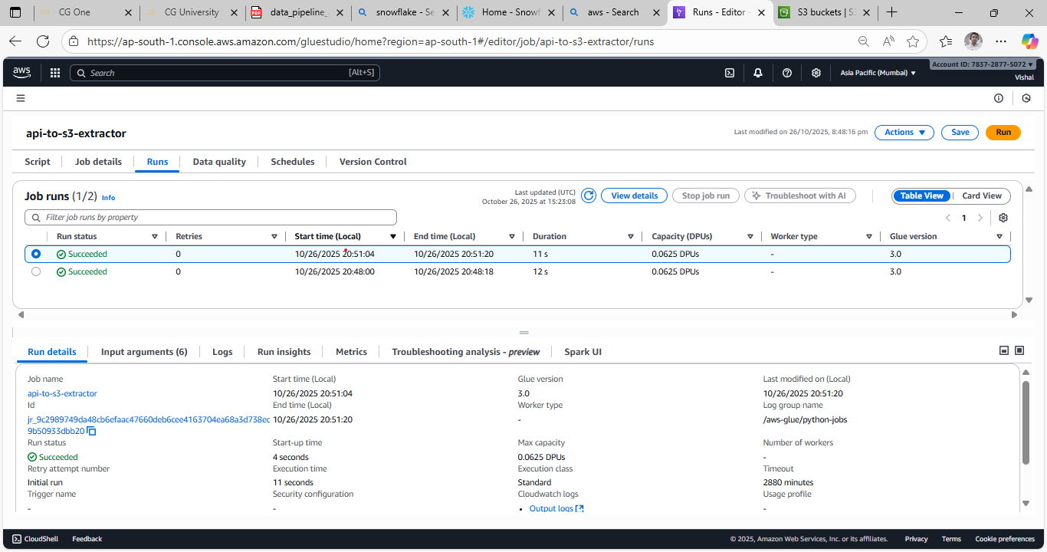

**3. Screenshot: File Stored in Cloud Storage**

This image shows the users.json file stored in the raw_data folder of the S3 bucket.

**4. Screenshot: Snowflake Raw Data Table**

This image shows the result of querying the raw data table (RAW_USERS), with each row containing the JSON for a single user.

Query: SELECT * FROM RAW_USERS LIMIT 10;

**5. Screenshot: Snowflake Transformed Data View**

This image shows the result of querying the final view (VW_USERS), which parses the JSON into clean, separate columns.

Query: SELECT * FROM VW_USERS LIMIT 10;

